During the Import Task, SPSS should have raised the alert: “Invalid variable names for this application have been found and changed”. Which two variables did this relate to and what were they changed to?

* I haven’t noticed any changes in the variable when comparing it to directly the excel spreadsheet.

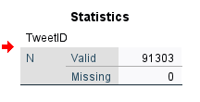How many cases were loaded in total?

* Number of cases that was imported onto SPSS = 91303

SPSS initially interprets the DateTime variable as a string type. What pattern did you use to import DateTime correctly?

* I converted the “type” on the variable type to the settings set in the image below
* 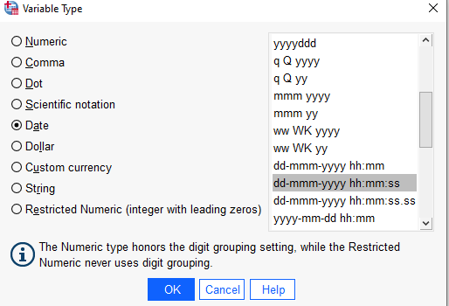The reason why I set it to this is show the format 23-Jun-2016 13:00:35 which is equal to dd-mmm-yyyy hh:mm:ss

How many variables has the data dictionary?

* After the import of the data from excel to SPSS, the variable shows 16

